Project Report from Mock Census

Summary
This data-driven project report in the form of an executive summary provides a mock demographic, social, and economic trends in a hypothetical town, how to present these trends to inform the local government’s future policy, and should, in this case, help inform on two policies:
- What should be built on the unoccupied plot of land?
- Which sector should have future investments?
I used visual, statistical, and inferential analysis from clean and explored data to justify my recommendation:
- The construction of a train station to support a growing commuter population.
- Investment in general infrastructure to support the town’s expanding needs.
The recommendations are based on empirical data, including age distribution, population growth, unemployment trends, religious affiliations, housing occupancy, birth and death rates, and other relevant metrics.

Introduction
The United Kingdom has a cycle of census every ten years to assess the demographics, useful in identifying trends and important information that informs policy and directs funding. In this project, we analyse a mock census dataset representing an imaginary town to stimulate real-world planning decisions. We aim to:
- Interpret patterns in age, occupation, religion, infirmities, and housing.
- Address local government planning needs using data-backed insights.
Materials and methods
Tools Used
- Jupyter Notebook for coding and visualisation.
- Libraries used are pandas, NumPy, seaborn, matplotlib for visualising required plots, and scipy.stats.
The methodology overview
- Data Cleaning: Handling missing values and correcting invalid inputs.
- Visualisation: Histograms, bar charts, and population pyramids
- Statistical Analysis: Summary statistics, proportions, rate per 100,000 population.
- Inference: Calculate birth/death ratio, religious inheritance, and household capacity.

Results and Discussion
Section A: Land development recommendation.
Recommendation: I would recommend a ‘train station’ be built for land development.
Commuter Identification: A manual tagging method was applied to get the proportion of commuters. The dataset contained over one thousand unique occupation entries, which were itemised using value counts. A custom selection function was used to manually select job titles typically associated with commuting (e.g., engineers, university students, medical professionals). The dataset was then filtered to include individuals in these occupations aged between 18 and 60. This yielded 3018 individuals of the total population (9285), resulting in approximately 32.5% who are commuters.
Employment Breakdown
- Employment rate is approximately 85.89%.
- Total unemployment rate in the general working-age population (16-65 years) is approximately 14.11%, with most individuals actively employed in different sectors.
Employment and commuter analysis: Employment trends reveal moderate unemployment rates. The community does not have a university institution; therefore, this shows a population of university students commuting elsewhere, and other professional groups also commute for work.
The key findings here are that a considerable proportion of the population commutes to neighbouring cities for employment and education. Current road infrastructure may struggle to manage future commuter demand as the population continues to increase.

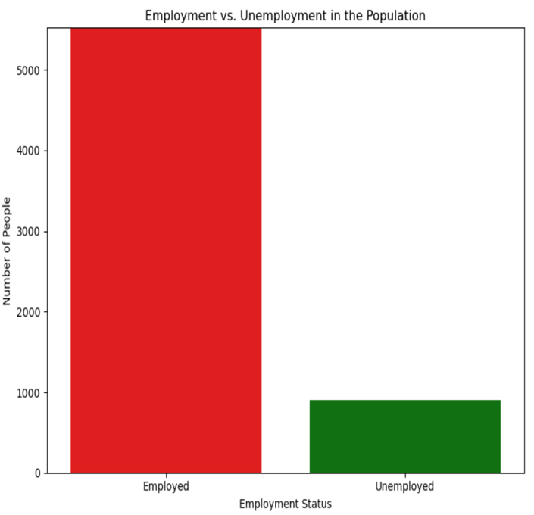 Fig1

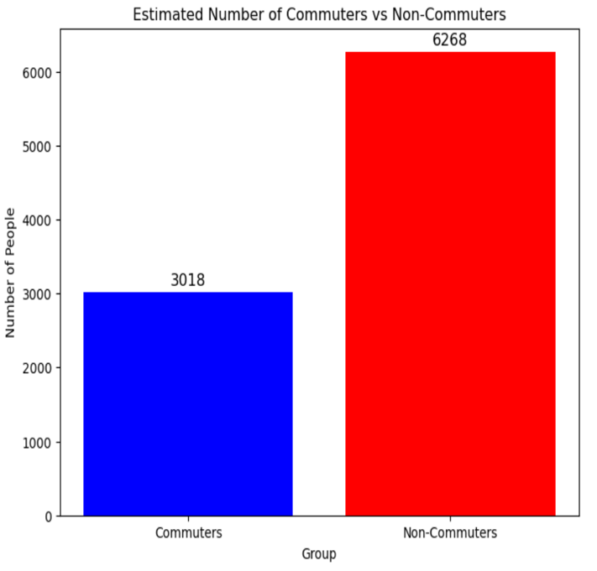 Fig2
Figures 1 & 2 bar plots above show the distribution of employed/ unemployed and the commuters and non-commuters.

From the plots, we can see the high value of employed individuals in the town, a percentage rate of 85.89% from the dataset analysis, which can affect transportation, leading to an increased number of vehicles on the roads and increased traffic congestion. Although non-commuters have a more increased percentage compared to commuters, but these non-commuters do not mean all the individuals are unemployed and sit at home or are hybrid workers. Of course, there are still jobs in the town where people move to daily and have their means of transportation.
The recommendation to develop a train station on the unoccupied land is a valid priority in several critical factors supported by the town’s demographic and economic data, which confirms that the town is experiencing net population growth, but not necessarily housing pressure. Natural growth (births exceed deaths), the birth rate among women aged 25-34 is estimated at 12,786 births per 100,000. In contrast, the total annual death rate across all age groups is 1,791.94 deaths per 100,000.
Net migration is also positive, which further validates the growth trend: estimated immigration rate 2,444.54 per 100,000 (based on lodgers/visitors settling), estimated emigration rate 1,786.56 per 100,000 (based on a fraction of divorced individuals leaving). Net migration rate is +658 per 100,000. When added to the natural growth component, this leads to a net population growth rate of 11,652.04 per 100,000, confirming the town is growing both biologically and through migration.
Despite the growth, is there housing pressure? Not yet, occupancy is low as the analysis reveals many households are underutilised. Comparing actual household size to the average occupancy per street shows widespread negative occupancy differences, especially in areas like Scott Avenue.
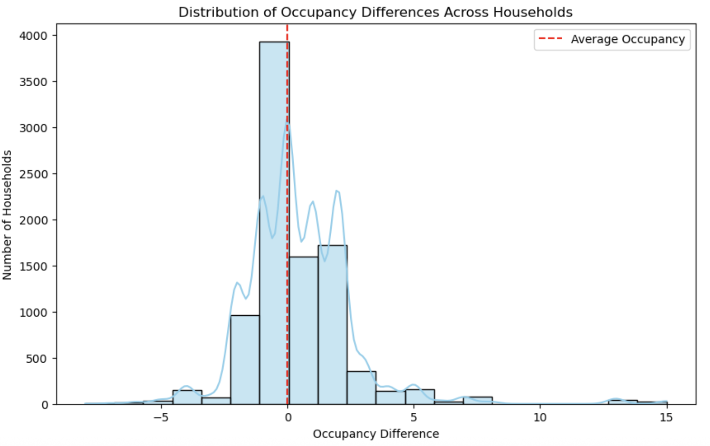 Fig. 3
Distribution of the occupancy difference plot.

Visual inspection of the occupancy difference histogram shows that most households fall to the left of the average occupancy line (dashed red), indicating underutilisation. This supports the conclusion that although the population is increasing, existing housing is not at full capacity.

A train station will reduce the dependence on private vehicles, and it will ease daily commuting for a sizeable proportion of the population. A train station is also cost-effective, as it would reduce the travel cost and time for workers and students, also sustainable to the environment with the reduction of carbon dioxide in the environment and improving overall quality of life.
Other positives we can draw from the development of a train station by the local government on the unoccupied land are, local businesses can begin to grow near the train station, creating new jobs, e.g., businesses like cafes, service industries, retail shops, etc. Also, investment can be attracted with an increase in the value of surrounding properties.
A train station acts as a catalyst for economic development by improving accessibility for businesses and residents. Rail stations are one of the ways to stimulate cities’ economic growth, unlock new areas for development, and enable widespread social, economic, and environmental transformation (Nothstine, 2023). On the other hand, if a town lacks a train station, the burden on the town’s infrastructure will grow, which will lead to urban congestion and reduced quality of life.

Recommendations on how to reduce congestion in cities/towns
To address congestion effectively in a growing small town, the following strategies are recommended.
- Build a Commuter Rail Station to Support Modal Shift.
As 32.5% of town residents are identified as commuters, establishing a train station on the vacant plot directly meets this need. Studies show that extending commuter rail systems decreases automobile travel and stimulates transit-oriented development (TOD).
A cross-city analysis shows that an increase in the supply of rail transport leads to less congestion, shorter travel times, and less pollution. Cities with a new rail system had an average, 7% less congestion, 1% lower travel times, and 3% less pollution than cities without a rail system (Fageda, 2021).
Impact: It provides essential infrastructure, cuts traffic on main roads, and enhances sustainable urban growth.

- Implement Transportation Demand Management (TDM)
Reducing congestion does not always require new roads. TDM policies such as congestion pricing, parking demand controls, and flexible commuting policies have proven highly effective. The TDM approach can shift travel behaviour and decrease congestion. For instance, Singapore’s Area Licensing Scheme saw a 76.2% fall in peak-hour. (Theseira, 2020) (p. 17). European pilots trialled tradable mobility credits and employer-based incentives, shown to curb car use during peak-demand periods (Tanner, Provoost and Cats, 2024) (Liu et al., 2022).
In addition, the success of TDM strategies goes further than not favouring peak-time private car use, they also generate new income that can be invested in public transport and infrastructure improvements, promoting a sustainable transport system.

- Encourage Flexible Arrangements and Staggered Shifts
Encouraging flexible working hours, remote or hybrid work models, and staggered shift start times, can spread out traffic evenly across the day. These practices help ease congestion by reducing the number of commuters during peak hours and promoting a better work-life balance as well as organisational productivity.
- Establish Urban Freight Consolidation Centres
Urban commuters are not the only ones who cause congestion. Deliveries to shops and businesses are another major contributor to congestion in city streets. Establishing freight consolidation centres at the edge of cities means goods can be grouped and delivered in fewer, cleaner vehicles during off-peak hours.
Impact: Less congestion caused by delivery vehicles, particularly in constrained city centres, and improves air quality.

Section B. General infrastructure
Why Infrastructure?
The town is seeing evidence of a consistent population growth pattern, and the reason for this appears to be that the rate of fertility is higher than the rate of mortality. For instance, the rate for women in the age group of 25-29 is about 26,389 per 100,000, the rate for women in the age group 30-34 in terms of births is also estimated at 29,504. In both of the indicated age groups, it can be assumed that such projections would lead to a continued upward trend when it comes to fertility rates. This trend is also well-confirmed by the population distribution by age and gender, in which the broad stability of both indicators is also apparent.
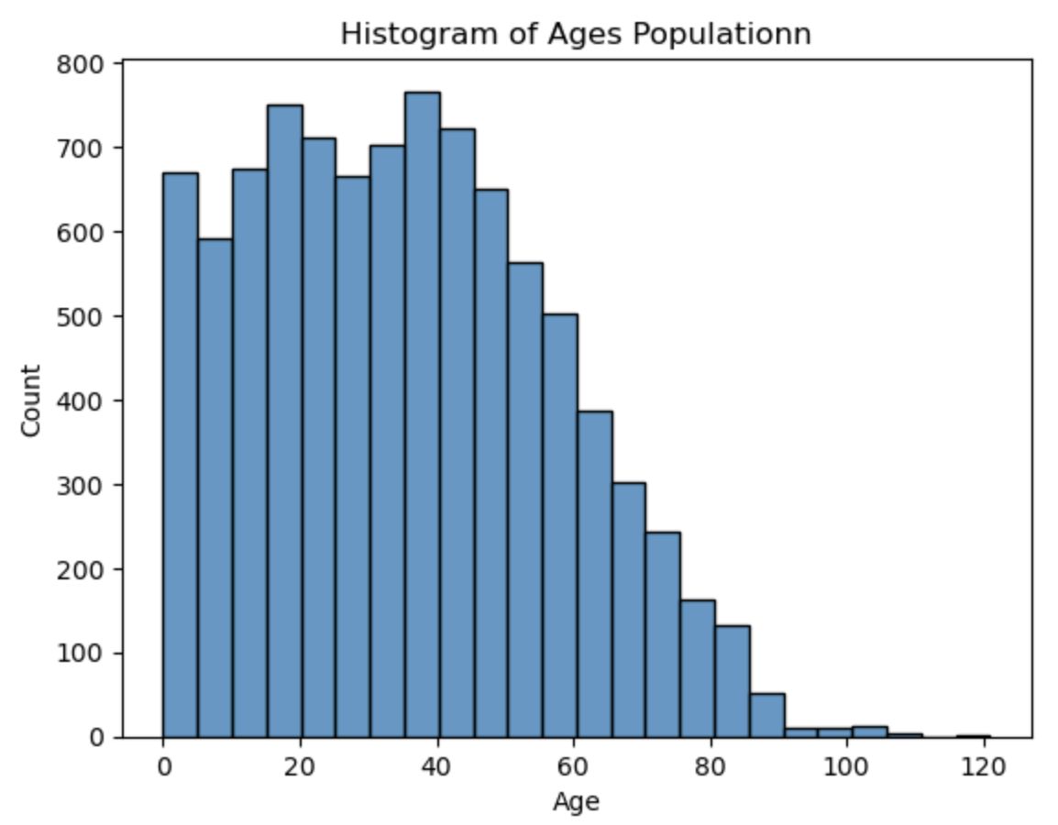
Fig.4. Age Histogram.
Fig. 4 shows high population counts in the working-age and young adult categories (20-45), denoting a relatively young and economically active population.
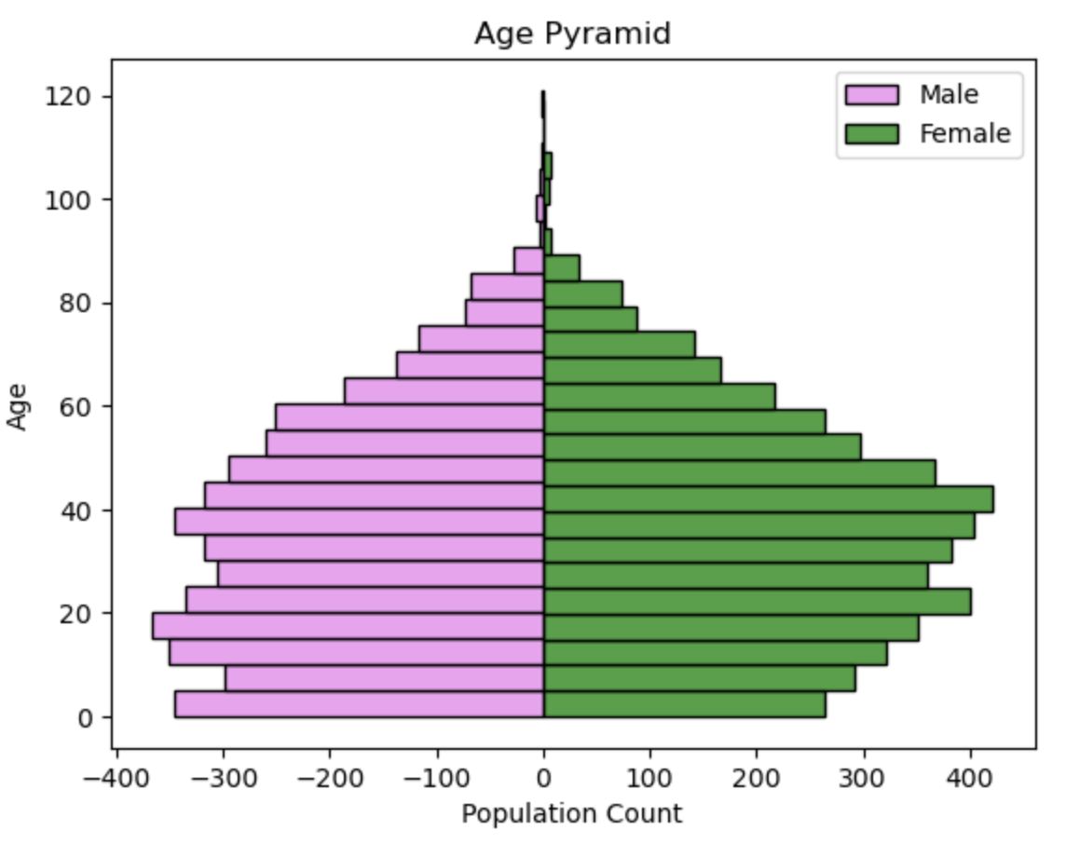
Fig.5. Population Age Pyramid.
Fig. 5 has a wide base, especially for females in the 20-40 age group, which indicates potential for future population growth through natural increase (births).
The general infrastructure assessment indicates that the projected growth in population will lead to additional demands on waste management, road maintenance, public transport, health care facilities, etc. It is therefore important to make proper improvements in these services if the town is to avoid a reduction in the quality of services, and the current infrastructure may be unable to cope with the predicted population growth.
Infrastructure is the backbone of any growing and thriving community. Infrastructure helps trade, powers commerce, transports workers to their jobs, provides opportunities for struggling communities, and shields the nation from an increasingly volatile natural world (Puentes, 2015).
In the context of our analysed population data, investing in general infrastructure is the most strategic decision to support the community’s current needs and future growth. The investment should prioritise critical sectors such as waste management, health care systems, and road maintenance. Each of these components plays an essential role in ensuring public health, safety, and overall quality of life.
The analysis from the dataset revealed that the birth rate per 100,000 women aged 25-29 has an approximate value of 26389, and the birth rate per 100,000 for women aged 30-34 yields an estimate of 29,504. We assume these are fertile ages for women. Looking at the birth rate compared to the death rate, there will be an increase in the population size in the future. The population growth will lead to more concentrated waste production in specific areas.

Also, as the population continues to increase, there will be heavy use of different road networks, and road maintenance is an important focus to aid sustainability. Road infrastructure offers a basic support system for the functioning of all national economies and social benefits. Proper maintenance of road infrastructure is vital in preserving and enhancing these benefits. Maintenance must be understood, funded, and well-managed by decision makers to realise maximum value. Under-investment and mismanagement of the road infrastructure trigger major consequences for society and the economy.
The values of any road network can be lost faster if not well maintained, and road users and society as a whole can experience significant negative impacts. Existing road networks may not be capable of handling increased traffic volumes, leading to faster wear and tear and higher accident risk.
Development of alternative transport routes can be recommended to handle the heavy reliance on only one source of transportation. Constructing more bypass roads and increasing lanes on high-traffic routes to decongest them. Allocating a fair investment in infrastructure for these sectors will bring essential sustainable growth, improvements in public health and safety of the citizens, while making the community more liveable and efficient. This infrastructure investment approach will aid in the town’s long-term growth and economic resilience while balancing the diverse needs of its citizens.

Recommendations to reduce the quantity of waste
These measures are recommended:
- Implement a Community-Driven Waste Segregation Program.
Promoting source separation of waste at the household and small business level into recyclable, organic, and residual waste can significantly enhance waste management. The process can be simplified by providing colour-coded bins and assigning designated collection days by the Local government.
- Collaborate with Community Recycling and Composting Cooperatives
Support micro-entrepreneurs and community composting initiatives with grants or land allocations. These kinds of partnerships can help the community become more sustainable and provide employment.
- Conduct Public Awareness on Waste Reduction and Recycling
Educating the public is essential and cannot be done in one campaign; it is a continuous and long-term process. This can be done through school programs, community discussion forums, online media, etc. The purpose of public education is to increase people’s understanding of how to reduce the amount of waste generated in the household, how to separate and sort waste, and to inculcate a habit of waste reduction and reuse.
- Designing a Variable Rate Pricing Structure for Waste Collection
Introduce a “Pay-As-You-Throw” (PAYT) fee program in which every household is charged for its non-recyclable waste according to quantity. The PAYT systems give households a financial incentive to waste less, recycle more, and compost organics at the source. In a meta-analysis of the academic literature, (Romano and Masserini, 2023) observed that PAYT implementation was associated with a reduction in the volume of total and unsorted municipal waste produced, as well as an increase in the amount and quality of separately collected materials.
Fairness and affordability may be achieved with discounted rates for low-income users or with tiered pricing.

Recommendation to conserve and sustain roads
Long-term maintenance of roads involves preventive maintenance to ensure their long-term integrity. Traffic and weather can degrade roads over time, so proactive routine maintenance can help ensure that they remain safe, reliable, and efficient.
- Execution and Adherence to a Preventive Road Maintenance Program
Roads are long-term capital assets that provide a good service for many years if they are properly maintained. Routine maintenance works such as crack sealing, resurfacing worn spots, and pothole repairs extend the life of road surfaces. Pavement management systems (PMS) can be an efficient tool as it is a software that allows tracking the state of roads and traffic intensity constantly, which helps to plan the road maintenance in time and avoid overruns.
- Focus on Durable, Locally Available Materials
Select durable materials that not only resist weather changes but are also easy to obtain and cost-effective for road projects. Materials like polymer-modified asphalt or interlocking concrete blocks provide durability and strength. Opting for local resources will also keep the overall costs low.
- Enable a Road Condition Feedback System Initiated by Citizens.
The development of a simple mobile application or SMS service that enables citizens to send in reports when they encounter potholes, erosion, waterlogging, and blocked drains or other problem conditions creates a type of early warning system that is triggered by those who use the roads on a day-to-day basis. This improves the responsiveness and cost-effectiveness of maintenance operations.
- Ensure Proper Drainage of Roads
Inadequate or poor drainage can be the reason for road damage. In high rainfall areas, one of the surest ways to prolong the lifespan of roads and other physical infrastructure is to ensure effective roadside drainage, culverts, and erosion protection measures to prevent the road surface and sub-surface from cracks and other damage.

Conclusion
It can be seen from the analysis and plots that the town is experiencing clear population growth, since both natural increase and net positive migration are occurring. While the housing stock appears underutilised, it does not yet require an expansion of housing. The birth rate is increasing, the number of people migrating into the town is increasing, and household structures are changing, which together are creating increased pressure on infrastructure and services.
In conclusion, a targeted infrastructure strategy prioritising a new train station and enhancing core services is the most sustainable path forward. It aligns with demographic realities, supports economic development, and ensures that the town remains liveable, resilient, and inclusive for years to come.
Reference

Fageda, X. (2021) 'Do light rail systems reduce traffic externalities? Empirical evidence from mid-size European cities', Transportation Research Part D: Transport and Environment, 92, pp. 102731.
Liu, R., Chen, S., Jiang, Y., Seshadri, R., Ben-Akiva, M. and Lima Azevedo, C. 2022. Managing network congestion with a trip-and area-based tradable credit scheme. Transportmetrica B: Transport Dynamics 0, 1–29.
Nothstine, A. a. S., Jack (2023) How rail station upgrades can drive wider urban change: Arup. Available at: https://www.arup.com/insights/how-rail-station-upgrades-can-drive-wider-urban-change/ 2025).
Puentes, R. (2015) 'Why Infrastructure Matters: Rotten Roads', Bum Economy.
Romano, G. and Masserini, L. (2023) 'Pay-as-you-throw tariff and sustainable urban waste management: An empirical analysis of relevant effects', Journal of Environmental Management, 347, pp. 119211.
Tanner, S., Provoost, J. and Cats, O. (2024) 'Tradable mobility credits for long-distance travel in Europe', Transportation Research Part A: Policy and Practice, 186, pp. 104156.
Theseira, W. 2020. Congestion Control in Singapore Discussion Paper. Paris: Organisation for Economic Cooperation and Development (OECD).

